Q1.

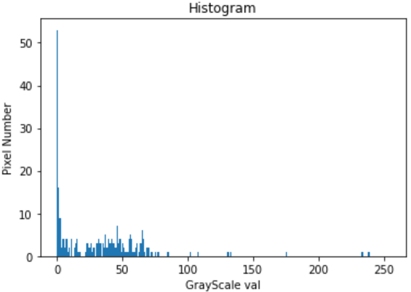

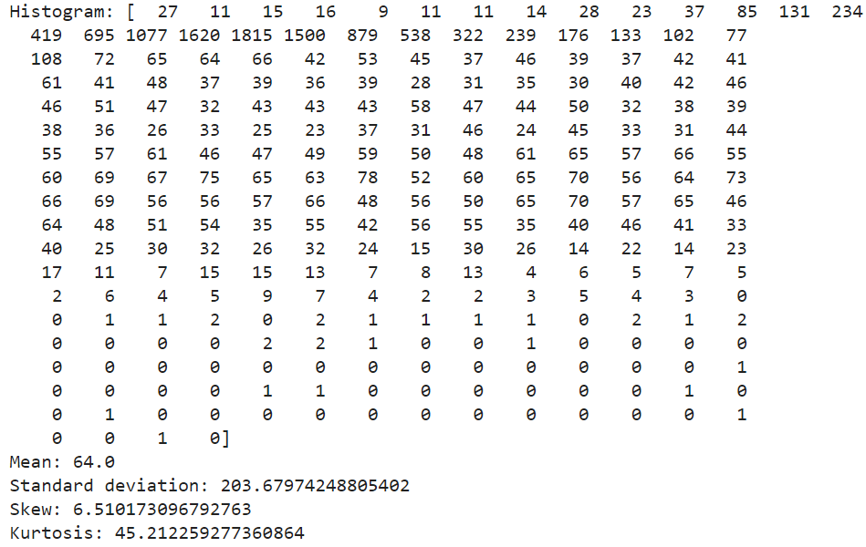

Q1. b) In code part

Q1. c)

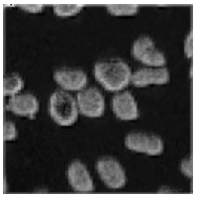

GLCM:

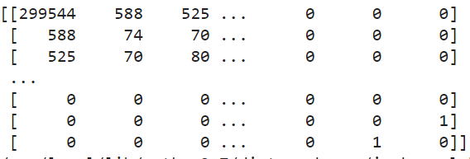

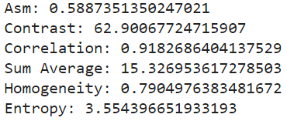

Q2.

Code present in file.

The first methodology was to formulate the given dataset into a pandas dataframe for convenience to pass it into the model for training and testing.

The function ‘glob.glob’ was utilized to traverse into the respective folders and load the train, test and validation dataset respectively. Separate lists were made for each of the train, test, validation images as well as corresponding labels.

Sklearn preprocessing methodology was utilized for performing one-hot encoding, for the labels. The distinct labels were 0, 1,2,3 for the separate respective classes of the images.

The datasets were also normalized, as per standard convention.

Finally, I used two different multilabel classification model, KNeighbor classifier and SVM to compare and observe. KNeighbour had an accuracy of 0.5961 on the test dataset and

0.55

on the validation test dataset. And so, SVM model was applied. On the validation dataset, the SVM had an accuracy of 1.0 and SVM yielded a higher accuracy for the test dataset, which was 0.92948.

The accuracy of KNeighbour classification can be increased further by including more features. And that would also help SVM to have a higher accuracy too (although it seems to be high).